Coworking Space Expand into Birmingham with Focus on Suburban Markets

By Illyshia Parker | Commercial Real Estate Reporter, Birmingham Business Journal

Mar 16, 2023
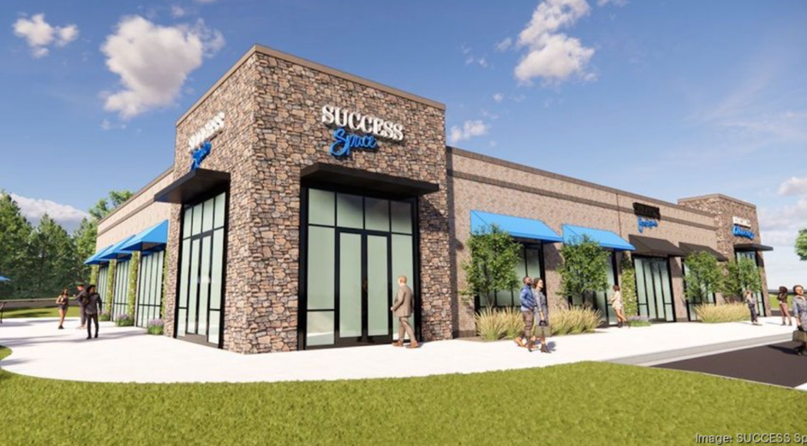
A new coworking concept is hitting the Birmingham market later this year for people seeking community and a place to work from.
SUCCESS Space is an emerging coworking concept that aims to move coworking away from urban cityscapes and toward suburban areas.
The company provides remote workspaces for on-demand rental where workers can stop in for 30 minutes or rent space for the 30 days. In addition to a cafe, work lounge, phone booths, work booths, micro-offices, private offices, conference room and podcasting studio with 24/7 QR code access, the company also offers onsite business coaching services.
Two locations are set to open in the Birmingham area with franchisees currently navigating the real estate site selection process. Homewood, Hoover and Vestavia Hills are being considered as possible franchise locations. The company is targeting a Q3 2023 opening of its first Birmingham location.
"We’ve identified Birmingham as a prime growth market for SUCCESS Space as resident’s have shown an increasing demand for coworking." Kelli Schroeder, VP of franchise development at SUCCESS Space. "We also know the city continues to prioritize economic development (its ranked in the top 10 best states to do business in the USA). As it stands, there’s several cowork concepts in the area, but none quite align with our goals — We want to bring cowork out to where the community lives and plays, which is the suburbs. Our goal is to be embedded in the local neighborhood, offering community through our services: cafe, cowork and coaching."
SUCCESS Space generally attracts solo-preneurs, such as Realtors or small business owners, and fully remote workers. The company targets both office and retail-based areas with a goal to be within 15 minutes or less of where someone might live, get groceries or pick up their dry-cleaning.
The initial SUCCESS Space investment ranges between $430,500 and $1 million, and each location creates 30 or more jobs.
Schroeder said that a location in the area stands to add millions of dollars in commercial real estate development, which ultimately puts the money back into the area and furthers the economic development of those suburban communities.
SUCCESS Space has locations in Texas, Louisiana, New York, California and Indiana.

